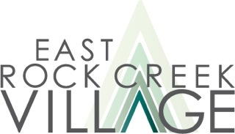

COVID Vaccine Updates
February 12, 2021

New Location for Safeway and Hattie Holmes Second Shot Appointments: Hattie Holmes Senior Wellness Center, 324 Kennedy St. NW, is closing for all vaccines, both first and second shots, on Monday, February 15. Those who already have an appointment to get a second shot at Hattie Holmes after the 15th will instead have appointments for the same day and time at a larger venue, Lamond Recreation Center, 20 Tuckerman St. NE (near the intersection of Tuckerman and Eastern Ave.).

Assistance in scheduling a second shot: Contact ERCV by email (preferred) or by phone at 202-656-7322 for assistance in making an appointment for a second shot if your first shot was at a Safeway pharmacy, Senior Wellness Center, or Lamond Recreation Center. Your second shot should be 28-31 days after the first one.

Vaccine Volunteers make appointments through DCHealth: ERCV’s group of volunteers are continuing to go online with DCHealth to obtain vaccine appointments for those 65 and older in northern Ward 4. On Thursday mornings they sign up for vaccine seekers living in zip code 20011 and on Friday mornings for those in 20012. Contact ERCV to request this service.

List for end-of-day or this-morning vaccines: ERCV members 65 and older, including newly-enrolled members, can be referred to be on a list to get vaccines in downtown DC on very short notice – 45 minutes to get downtown after a phone call. Availability is unpredictable. Contact us by email if you would like to get on the list.

Free medical rides including to vaccine appointments: ERCV members can request rides to medical appointments. Membership is open to residents of Ward 4 living east of Rock Creek Park and north of Missouri Ave. and is free during the pandemic.

